# SMART BRIDGE USING ARDUNI0

# 

# A MINI PROJECT REPORT SUBMITTED BY

# 

**ABIRAMI.E(312422106002)**

***In partial fulfilment of co-curricular activities***

***Organized by***

# DEPARTMENT OF ELECTRONICS AND

**COMMUNICATION ENGINEERING**



**ST. JOSEPH’S INSTITUTE OF**

**TECHNOLOGY OMR, CHENNAI-600119**

**TABLE OF CONTENT**

|  |  |  |
| --- | --- | --- |
| **S.NO** | **CONTENT** | **PAGE NO** |
| **1** | **INTRODUCTION** | **3** |
| **2** | **COMPONENTS** | **4** |
| **3** | **BLOCK DIAGRAM** | **8** |
| **4** | **WORKING** | **10** |
| **5** | **CONCLUSION** | **10** |

## INTRODUCTION

This introduction presents a cutting-edge approach to bridge management and safety through the implementation of a Smart Bridge Elevation Control System (SB-ECS) using Arduino, an soil moisture sensors, and servo motors. When moisture levels indicate potential instability,the smart bridge autonomously initiate its rising mechanism,ensuring preemptive action to prevent structural issues and prioritize user safety. When water levels rise to potentially hazardous levels, the Arduino-based control system engages servo motors to automatically adjust the bridge’s height, ensuring the safety of bridge and vehicles.

The Smart Bridge Elevation Control System combines real-time data collection and analysis, offering bridge operators critical information for decision-making during flood events or changing water conditions. By incorporating servo motors, the system achieves precise and responsive bridge elevation adjustments, reducing the risk of accidents, structural damage, and road closures during flooding. Moreover, it enhances infrastructure resilience, contributing to safer and more efficient transportation networks.

## COMPONENTS USED

* [Arduino UNO](https://robu.in/?category=&s=arduino+uno&search_posttype=product)
* USB A to B
* Breadboard
* [DHT11 sensor](https://robu.in/?category=&s=dht11&search_posttype=product)
* [DC Fan](https://robu.in/?category=&s=5v+fan&search_posttype=product)
* [2n2222 transistor](https://robu.in/product/2n2222-npn-transistor-pack-of-20/)
* [16x2 LCD](https://robu.in/?category=&s=16x2&search_posttype=product)
* [Connecting wires](https://robu.in/product/10-cm-40-pin-dupont-male-male-male-female-female-female-cable-combo/)

**HARDWARE SPECIFICATIONS**

**ARDUINO UNO**

* A number of pins, which are used to connect with various components you might want to use with the Arduino. These pins come in two varieties:

o Digital pins, which can read and write a single state, on or off. Most Arduinos have 14 digital I/O pins. o Analog pins, which can read a range of values, and are useful for more fine-grained control. Most Arduinos have six of these Analog pins.

These pins are arranged in a specific pattern, so that if you buy an add-on board designed to fit into them, typically called a “shield,” it should fit into most Arduino-compatible devices easily

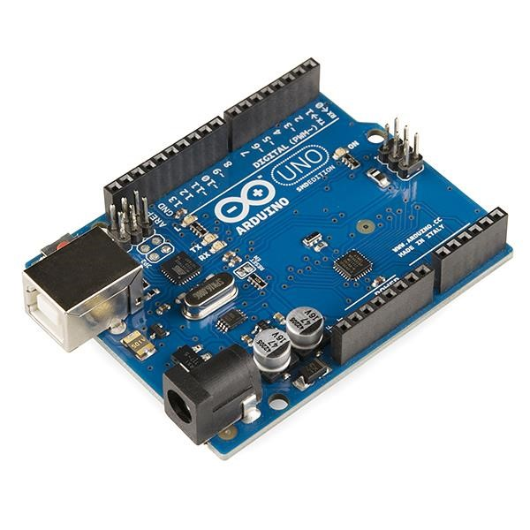

### USB A TO B

Without a doubt, USB-A is the most common USB cable, and it is often the first that comes to mind when you hear the word "USB." Type-A supports all versions of USB and is found on virtually every piece of modern technology. This rectangular shaped plug is used for many devices like flash drives and often is one end of a cable for all the other types of USB like Micro or USB-C.

For instance, many USB cables will have a USB-A end to connect to a PC or power adapter, and another type on the other end to connect to a specific device. With most phone chargers, for example, the end that plugs into the wall adapter will be a USB Type-A cable.

USB-B has a smaller, squarer connector and is used most commonly with printers and scanners. With these cables, one end is typically Type-B while the other is Type-A to connect to a computer. Past its prime, B-Type USB cables are finding less use with the introduction of wireless printers and other new technology. USB-B cables, however, still support USB version 3.1, so you can expect to see them for a while longer.

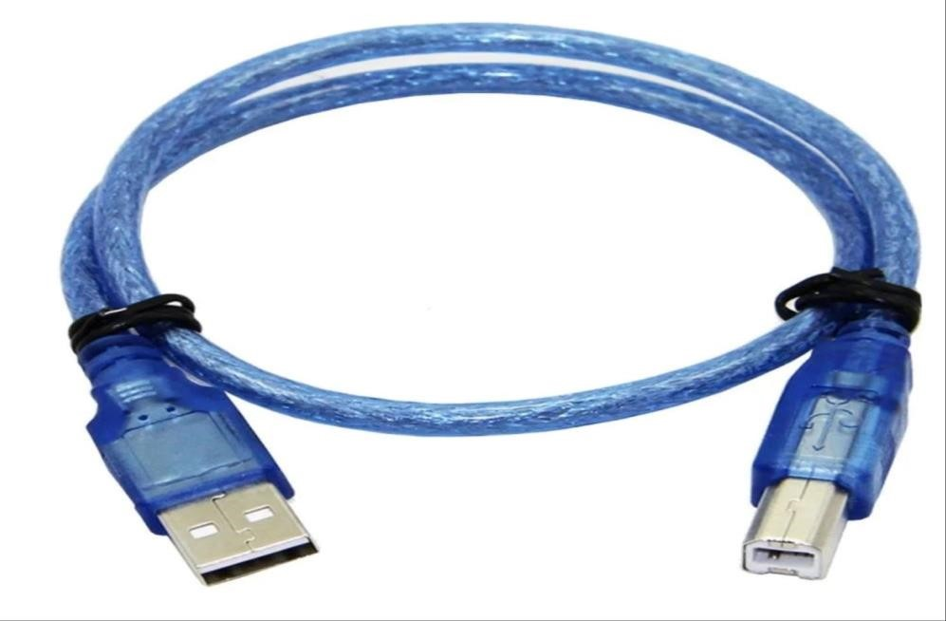

### DHT11 Sensor

The **DHT11** is a commonly used **Temperature and humidity sensor that** comes with a dedicated NTC to measure temperature and an 8-bit microcontroller to output the values of temperature and humidity as serial data.

The sensor can measure temperature from 0°C to 50°C and humidity from 20% to 90% with an accuracy of ±1°C and ±1%. So if you are looking to measure in this range then this sensor might be the right choice for you.

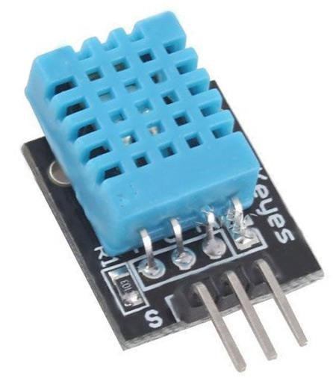

### DC FAN

In simple terms, a [DC fan](http://www.leipole.net/) is a cooling fan that converts electrical energy into electromagnetic energy through DC voltage and electromagnetic induction, and then electromagnetic energy into mechanical energy, and finally into kinetic energy, so that the fan blades rotate.

The DC fan is mainly composed of four parts: rotor, stator, motor, and outer frame. as follows:

1. DC motor composition: it is composed of permanent magnet rotor, multi-stage winding stator, position sensor, and electronic commutation drive control circuit.
2. Rotor composition: It is composed of motor shell, permanent magnetic strip, shaft core and fan blades.
3. Stator part: enameled wire, plastic-coated silicon steel sheet, bearing, Hall sensor detection, drive circuit board and shaft.

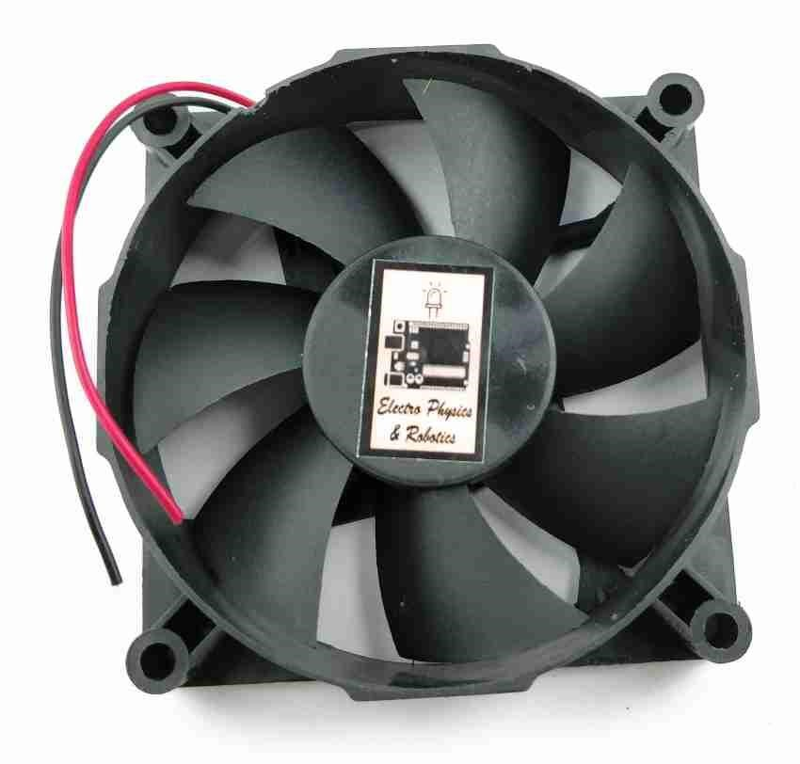

**NPN TRANSISTOR**

2N2222A is a NPN **transistor** hence the collector and emitter will be left open (Reverse biased) when the base pin is held at ground and will be closed (Forward biased) when a signal is provided to base pin. 2N2222A has a gain value of 110 to 800, this value determines the amplification capacity of the transistor. The maximum amount of current that could flow through the Collector pin is 800mA, hence we cannot connect loads that consume more than 800mA using this transistor. To bias a transistor we have to supply current to base pin, this current (IB) should be limited to 5ma..

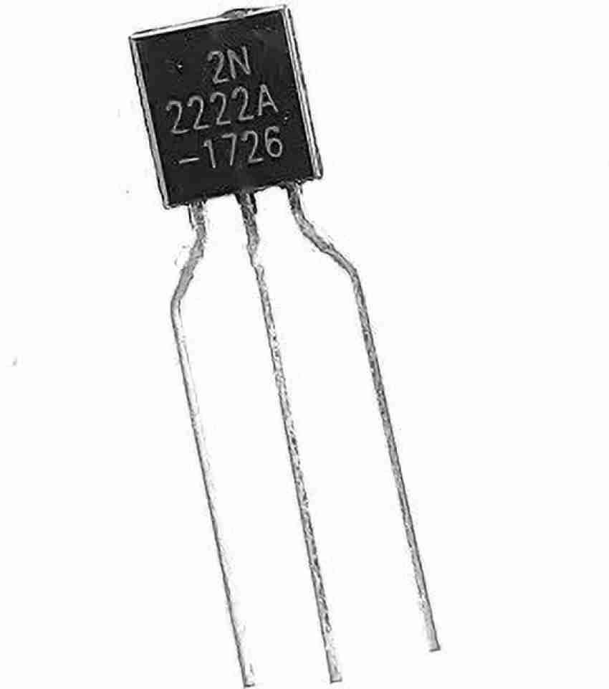

### 16*2 LCD DISPLAY

16x2 Character LCD Display WH1602W is having two pinout interfaces on upper and bottom sides of the LCD module. This 16x2 lcd display has the outline size of 80.0 x 36.0 mm and VA size of

66.0 x 16.0 mm and the maximum thickness is 13.2 mm. WH1602W 16x2 LCD Displays are built-in controller ST7066 or equivalent. It is optional for + 5.0 V or + 3.0 V power supply. The LEDs can be driven by pin 1, pin 2, or pin 15 pin 16 or A/K. This type of module can be operating at temperatures from -20℃ to +70℃; its storage temperatures range from -30℃ to +80℃.

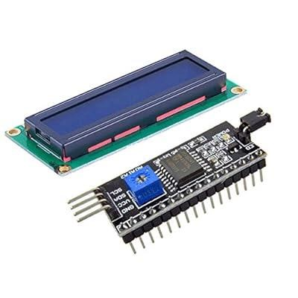

### CIRCUIT DIAGRAM

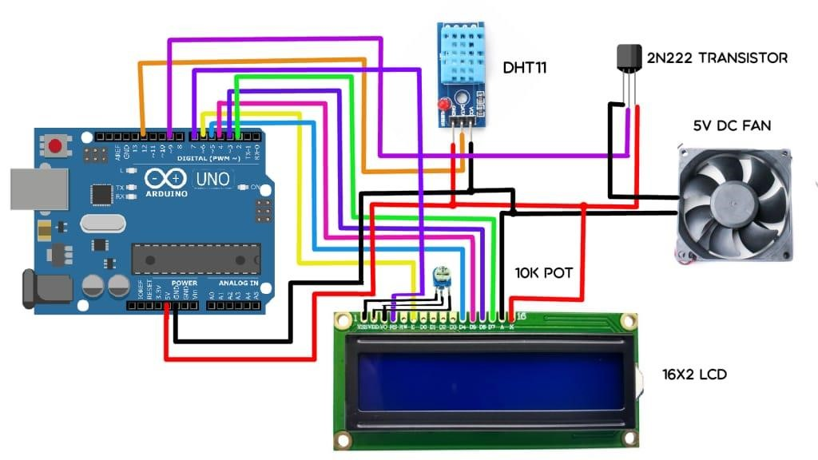

### REFERENCE IMAGE

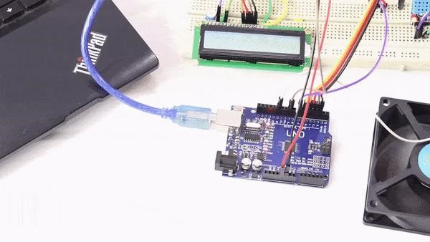

**BLOCK DIAGRAM:**

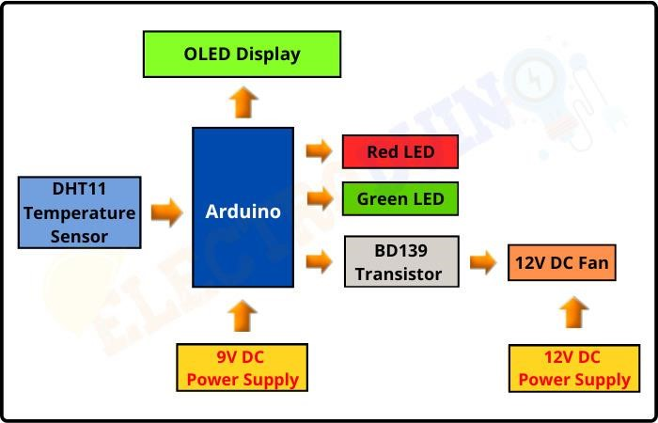

### WORKING

This project works in three parts -

In the first step, the sensor senses the temperature by temperature and humidity sensor namely ***DHT11****.*

In the second step, the sensor's output is taken and conversion of temperatur**e** value into a suitable number in Celsius scale is done. The fan speed is controlled by using PWM signals. And last part of the system shows humidity and temperature on LCD and Fan runs.

Then we have programmed our Arduino according to the requirements. Working on this is very simple. We have generated PWM from Arduino and put it at the base terminal of the transistor. Then transistor generates voltage with respect to the PWM

**CONCLUSION:**

We learned about, how we can make a temperature-controlled fan circuit. Using an Arduino, DHT11, and few other components. Which can be used pretty much any place where temperature needs to be maintained at specific levels. Like in some industries, houses, etc. We checked how it actually works and we also learned how to code for a temperature-controlled fan

10